 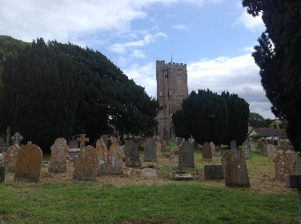 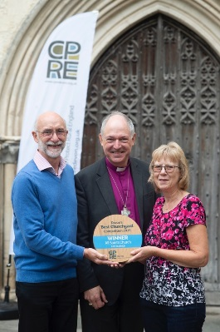

Devon’s Best Churchyard Competition 2020

Devon’s historic churches play a pivotal role in our rural communities and form a unique part of our cherished landscape. After all, they are the only unchanged places in some parishes since Saxon times. Churchyards therefore provide ideal habitats for our precious wildlife.

CPRE Devon is again organising a competition to determine **Devon’s Best Churchyard.**

The winning entry will receive a cheque for £200.00, a plaque and membership to CPRE Devon for one year.

* The competition aims to recognise and reward Devon churchyards which are well managed, providing a **peaceful haven for both people and wildlife.** We encourage entries from churchyards of all denominations.
* Does your churchyard strike a balance between being **an area of peace and contemplation whilst allowing nature to flourish?**
* Do you **actively encourage and help sustain wildlife into** your churchyard?
* Do you have volunteers who work tirelessly to maintain an **attractive and welcoming churchyard?**

Entries may be submitted by any organisation which is responsible for managing a

churchyard. **If you are proud of your churchyard and those who work in it, then please consider entering this FREE competition.**

Entries must be received by Tuesday 31st March 2020. Judging will take place during the period of April to August. Winners will be announced by 30th September 2020 when prizes will be awarded.

Entry forms can be downloaded at [www.cpredevon.org.uk](http://www.cpredevon.org.uk) and returned to us at the address below (post or email)

**CPRE Devon – *The Voice for Devon’s Countryside***

PO Box 26, Beaworthy, Devon EX21 5XN Tel: 01392 966737 email: [info@cpredevon.org.uk](mailto:info@cpredevon.org.uk)

*The Devon Branch of the Campaign to Protect Rural England CIO*

*A charitable incorporated organisation with registered charity number 1175228*