 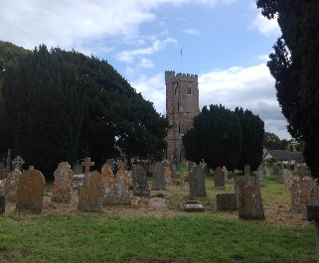 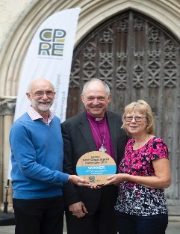

Devon’s Best Churchyard Competition 2020

ENTRY FORM

Name of Town/Village/Parish:

Name of Church:

Name of Contact:

Address: ........................................................................................................................................................................................................................................................................................................................................................................Postcode: .......................................................................................................

Email: .............................................................................................................

Tel: .................................................................................................................

Directions to the churchyard entered into the competition:

…………………………………………………………………………………….....

……………………………………………………………………………………….

………………………………………………………………………………………

Please provide information regarding how your churchyard is wildlife friendly, how it is managed and what wildlife has been seen. The information you provide, whether photographs, a short profile/leaflet or records of wildlife, will be used by the judges when we visit and should accompany this entry form.

Other useful information to include is:

- **Your grass cutting regime**; do you mow at a variety of times, leave flowers to seed before cutting and how do you dispose of mowings?

- **Planting;** any recent planting of trees, shrubs or other plants.

- **Habitat;**do you have bird, bat, insect boxes or log piles? Are gravel kerbs and headstones left in place to protect lichens?

- **Information;** any plans or notices/noticeboards displayed, for visitors or an information leaflet to show how the churchyard is looked after for wildlife.

- **Facilities;** what facilities are provided for people to make it a special place – eg seats/benches, other?

- **Who;** how many people (and who) are involved with the care of the churchyard. For example, local schools, youth clubs or other organisations. Is the churchyard used for any teaching purposes appertaining to wildlife?

- Have you visited any other conservation churchyards?

**The judges visit each churchyard and graveyard entered.** So, if you   
think your churchyard is good for wildlife and/or is a special sanctuary for people, or would like advice on how to make it better, why not enter our free competition?

All you have to do is complete the entry form which will give you some idea of the things the judges look at, whilst telling them something about what you are doing in your churchyard. When complete, send your entry to: CPRE Devon, PO Box 26, Beaworthy, Devon EX21 5XN Attn Ivan Buxton

Or Email: [info@cpredevon.org.uk](mailto:info@cpredevon.org.uk)

If emailing photographs kindly attach them in jpg (jpeg) format and in small size, preferably 640x480

**The closing date for entries is: 31 March 2020**

CPRE Devon – *The Voice for Devon’s Countryside*

PO Box 26, Beaworthy, Devon EX21 5XN Tel: 01392 966737 [info@cpredevon.org.uk](mailto:info@cpredevon.org.uk)

The Devon Branch of the Campaign to Protect Rural England CIO

A charitable incorporated organisation with registered charity number 1175228